# Storage BQ-API

# Implement data validate <2019 and > current+1 year

Incident: open and close incident

Pm-plan : planned-data and ended data

Incident detail: start and end

Pm_item inventoru : enginerr and document data

Inventory : start and end warranty

Project: start and edn

# Log & Email

365 email djaong

How to Log (data or text file or event log)

# Test CAse

Update view xyz_incditn form de to productiok

Check data edit to alling xyz

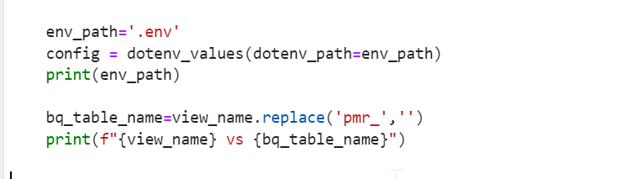

And if ba-stragte is not is_deletete filed

Chenca g15 ti 18 contentyy fo rinceident



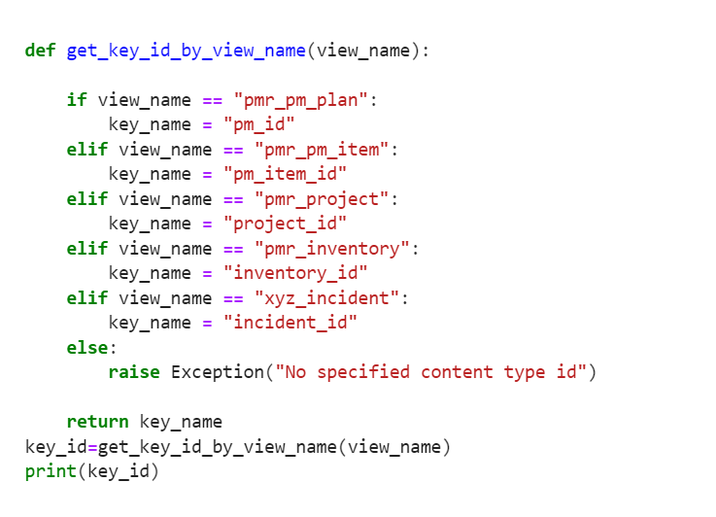

chnage